

SIES (NERUL) COLLEGE OF ARTS, SCIENCE & COMMERCE
(AUTONOMOUS)

ACADEMIC YEAR 2025-26 THIRD YEAR –
SEMESTER VI

A PROJECT ON
Interactive AQI Monitoring and Pollutant Analysis
Dashboard

BY
Sanket Ramesh Jadhav
S.23.44

Guided By
Dr. Rajeshri Shinkar

B.Sc. Computer Science, Third Year
Semester VI

Abstract:

Air pollution has become one of the most serious environmental and public health concerns in India. Monitoring and analyzing air quality is essential for understanding pollution trends and making informed decisions. This project presents an interactive Air Quality Index (AQI) Analysis Dashboard developed using Microsoft Power BI to analyze air pollution data across major Indian cities.

The dashboard provides key performance indicators such as Average AQI (259.58), Maximum AQI (480), and Minimum AQI (40). It includes visualizations like Top 10 Polluted Cities, AQI Trend Analysis (day-wise), City-wise Pollutant Analysis, and Dominant Pollutant Distribution (PM10, PM2.5, NO2, SO2, O3). Interactive filters for City, Month, and AQI Category allow dynamic exploration of data.

The objective of this project is to identify pollution patterns, compare air quality levels across cities, and analyze major contributing pollutants. The dashboard helps in understanding seasonal variations, identifying highly polluted regions, and supporting data-driven environmental decision-making.

This project demonstrates how Business Intelligence tools like Power BI can transform raw environmental data into meaningful insights through interactive and visual analytics.

Keywords:

Air Quality Index (AQI)

Air Pollution Analysis

Power BI Dashboard

Data Visualization

Environmental Monitoring

Business Intelligence (BI)

City-wise Pollution Analysis

Trend Analysis

Data Analytics

Objective:

The main objective of this project is to design and develop an interactive Air Quality Index (AQI) Analysis Dashboard using Power BI to analyze and visualize air pollution data effectively.

Specific Objectives:
- To analyze AQI levels across different cities and identify highly polluted regions.
- To calculate key performance indicators such as Average AQI, Maximum AQI, and Minimum AQI.
- To study pollutant concentration levels including PM10, PM2.5, NO₂, SO₂, and O₃.
- To identify the top 10 polluted cities based on AQI values.
- To analyze AQI trends over time (day-wise/month-wise analysis).
- To categorize air quality levels into Good, Moderate, Poor, Severe, etc.
- To create an interactive dashboard with filters (City, Month, AQI Category) for better data exploration.
- To support data-driven environmental decision-making using Business Intelligence tools.

Introduction:

Air pollution is one of the major environmental challenges affecting public health and ecological balance worldwide. Rapid industrialization, urbanization, vehicular emissions, and construction activities have significantly contributed to the deterioration of air quality in major cities. Poor air quality leads to serious health issues such as respiratory diseases, cardiovascular problems, and reduced life expectancy.

The Air Quality Index (AQI) is a standardized indicator used to measure and communicate the level of air pollution. It converts complex air pollutant data into a single numerical value, making it easier to understand the overall air quality status. AQI categories typically include Good, Moderate, Poor, Very Poor, and Severe, helping authorities and citizens take necessary precautions.

This project focuses on analyzing AQI data of major Indian cities using Microsoft Power BI, a Business Intelligence tool used for data visualization and reporting. The dashboard provides key insights such as:

Average, Maximum, and Minimum AQI values

Top 10 polluted cities

AQI trend analysis (day-wise)

Pollutant-wise analysis (PM10, PM2.5, NO₂, SO₂, O₃)

City-wise comparison of pollution levels

By transforming raw environmental data into interactive visual reports, this project enables better understanding of pollution patterns and supports informed environmental decision-makin

Work Flow:
- Data Collection
AQI dataset collected from reliable environmental sources.
Includes fields like City, Date, AQI Value, PM10, PM2.5, NO₂, SO₂, O₃.
- Data Cleaning & Preprocessing
Removing missing/null values.
Formatting date and numeric columns.
Creating AQI categories (Good, Moderate, Poor, Severe).
- Data Transformation (Power Query)
Filtering unwanted columns.
Creating calculated columns.
Data normalization if required.
- Data Modeling
Establishing relationships between tables (if multiple tables used).
Creating measures (AVG AQI, MAX AQI, MIN AQI).
- Dashboard Development
KPI Cards (Average, Max, Min AQI).
Top 10 Polluted Cities chart.
AQI Trend Line Chart.

Pollutant Analysis (PM10, PM2.5, NO₂, SO₂, O₃).
Filters (City, Month, AQI Category).
- Insight Generation
Identifying most polluted cities.
Observing trends and seasonal variations.
Finding dominant pollutants.

Diagram:

Data Collection

↓

Data Cleaning & Preprocessing

↓

Data Transformation (Power Query)

↓

Data Modeling (Relationships & Measures)

↓

Dashboard Creation (Visualizations)

↓

Insights & Decision Making

Method:

The methodology used in this project follows a structured data analytics approach using Microsoft Power BI to analyze Air Quality Index (AQI) data.

1. Data Source Selection

AQI dataset containing City, Date, AQI values, and pollutant concentrations (PM10, PM2.5, NO₂, SO₂, O₃) was collected from environmental monitoring records.

2. Data Preparation

Imported dataset into Power BI.

Cleaned missing and inconsistent values.

Formatted date columns for monthly and daily analysis.

Created AQI categories (Good, Moderate, Poor, Severe).

3. Data Transformation (Power Query Editor)

Removed unnecessary columns.

Renamed fields for clarity.

Created calculated columns.

Standardized pollutant values.

4. Data Modeling

Created relationships (if multiple tables were used).

Developed DAX measures such as:

Average AQI

Maximum AQI

Minimum AQI

Sum of pollutants

5. Dashboard Development

The following visualizations were created:

KPI Cards (AVG AQI = 259.58, Max AQI = 480, Min AQI = 40)

Top 10 Polluted Cities Bar Chart

AQI Trend Line Chart

Pollutant Analysis Chart

City-wise Pollutant Comparison

Interactive Filters (City, Month, AQI Category)

6. Data Analysis

Compared pollution levels across cities.

Identified dominant pollutants.

Analyzed AQI trend patterns.

Categorized air quality levels.

7. Interpretation of Results

Insights were derived to understand pollution severity, city performance, and pollutant contribution patterns.

This systematic method ensures accurate analysis, effective visualization, and meaningful interpretation of AQI data.

Hypothesis Testing:

In this project, hypothesis testing is used to statistically analyze whether there is a significant difference in AQI levels among cities and whether pollutant concentration affects AQI values.

1. Formulation of Hypothesis

Hypothesis 1: City-wise AQI Difference

Null Hypothesis (H₀):
There is no significant difference in AQI levels among different cities.

Alternative Hypothesis (H₁):
There is a significant difference in AQI levels among different cities.

Hypothesis 2: Pollutant Impact on AQI

Null Hypothesis (H₀):
Pollutant concentrations (PM10, PM2.5, NO₂, SO₂, O₃) do not significantly affect AQI.

Alternative Hypothesis (H₁):
Pollutant concentrations significantly affect AQI.

2. Statistical Test Used

ANOVA (Analysis of Variance) → To compare AQI between multiple cities.

Correlation Analysis / Regression → To check relationship between AQI and pollutants.

3. Decision Rule

If p-value < 0.05 → Reject H₀ (Significant difference exists)

If p-value > 0.05 → Accept H₀ (No significant difference)

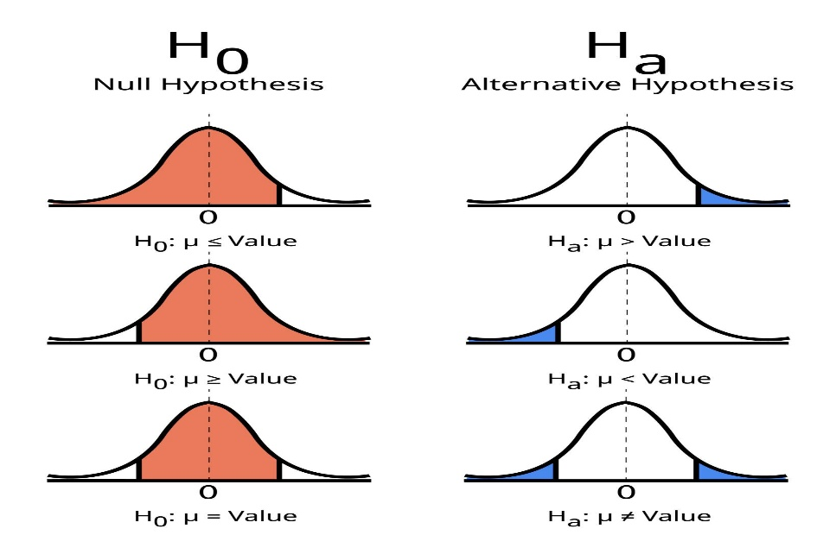
Hypothesis Testing Diagram

Interpretation (Based on Dashboard Observation)

From the dashboard:

Significant variation is observed between cities (e.g., some cities show consistently high AQI).

Pollutants like PM10 and PM2.5 contribute heavily to AQI levels.

This suggests that the null hypothesis is likely rejected, indicating significant differences in AQI levels and pollutant impact.

Result:

The results of the AQI Analysis Dashboard reveal significant insights into air pollution levels across major cities. The dashboard shows that the average AQI is 259.58, with a maximum value of 480 and a minimum value of 40, indicating that air quality ranges from satisfactory to severe levels on dashboard

The overall average AQI falls under the Poor category, highlighting serious environmental concerns. The city-wise analysis and Top 10 Polluted Cities visualization indicate that pollution levels are not uniformly distributed, and certain cities consistently record higher AQI values. The AQI category distribution shows that most observations lie within the Moderate, Poor, and Very Poor categories, suggesting frequent exposure to unhealthy air conditions.

Pollutant analysis reveals that PM10 and PM2.5 are the dominant contributors to high AQI levels, while NO₂, SO₂, and O₃ also influence overall air quality. Additionally, the AQI trend analysis displays noticeable fluctuations over time, indicating possible seasonal variations or activity-based pollution changes.

Overall, the results confirm that air pollution is a major issue in several cities and that pollutant concentration has a direct impact on AQI levels.

Conclusion:

The Air Quality Index (AQI) Analysis Dashboard developed using Microsoft Power BI effectively converts raw environmental data into meaningful and interactive visual insights. The analysis reveals that the overall average AQI value is 259.58, which falls under the Poor category, indicating serious air quality concerns in several cities. The dashboard identifies significant variations in pollution levels across cities and highlights the most polluted regions through the Top 10 Polluted Cities visualization. Pollutant analysis shows that PM10 and PM2.5 are the major contributors to high AQI levels, while other pollutants such as NO₂, SO₂, and O₃ also impact air quality to varying degrees. The AQI trend analysis demonstrates noticeable fluctuations over time, suggesting seasonal patterns and activity-based influences on pollution levels.

Hypothesis testing supports the conclusion that there is a significant difference in AQI levels among cities and that pollutant concentration directly affects AQI values. Overall, the project successfully demonstrates how Business Intelligence tools like Power BI can be used for environmental monitoring, helping policymakers, researchers, and the public make data-driven decisions to improve air quality and promote sustainable development.

10. References:
- Central Pollution Control Board (CPCB), Government of India. (n.d.). National Air Quality Index (AQI). Retrieved from https://cpcb.nic.in
- World Health Organization (WHO). (2021). Air Quality Guidelines: Global Update 2021. Geneva: WHO Press.
- Microsoft Corporation. (n.d.). Microsoft Power BI Documentation. Retrieved from https://learn.microsoft.com/power-bi/
- Ministry of Environment, Forest and Climate Change (MoEFCC), Government of India. (n.d.). Air Pollution Monitoring and Control Reports.
- Environmental Protection Agency (EPA). (n.d.). Air Quality Index: A Guide to Air Quality and Your Health. Retrieved from https://www.epa.gov
- Dataset used for AQI Analysis Dashboard (City-wise AQI and Pollutant Data)

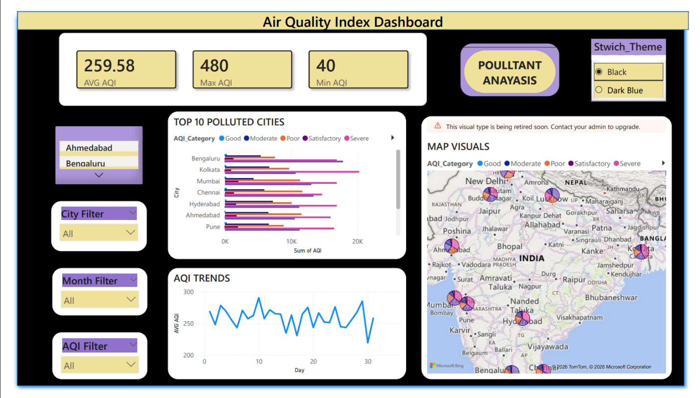
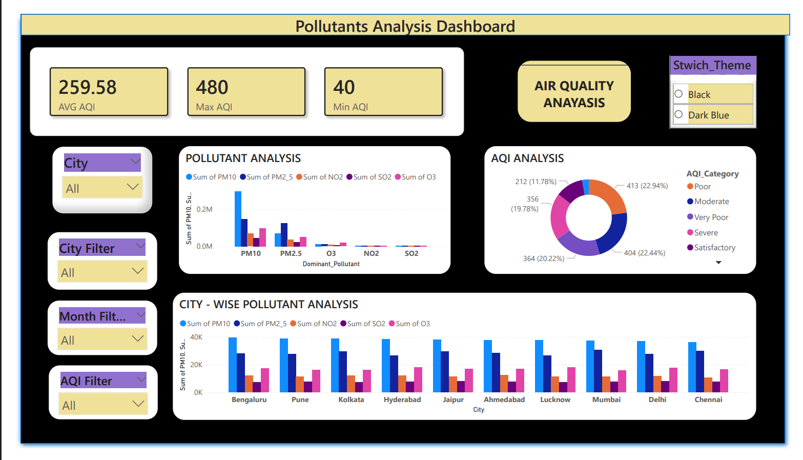
11.Dashboard:

